6. First Milestone: High-Fidelity Prototype

6.1 Introduction

This chapter explores the several steps taken to create the high-fidelity prototype. The phases involved are: low-fidelity prototype, initial high-fidelity prototype and final high-fidelity prototype. In each phase the steps and difficulties encountered, if any, will be discussed.

6.2 Low-Fidelity Prototype

The low-fidelity prototype also known as paper-based prototype (see Appendix L) was captured on a piece of paper. This made editing designs easy.

After signing in on Screen 1, you are navigated to screen 2, which shows the coaching sessions for a particular coaching programme or pathway. The first coaching session, titled “Title 1” is not booked whilst the second coaching session is booked. Each coaching session has a PDF material, which the Coachee can choose to download and read. The “Action” drop-down menu displays a list of actions that can be performed on the coaching session e.g. “book a session”, “delete a booked session” etc.

On Screen 2, the drop-down menu, right under the “Programmes” title on navigation bar, displays a side menu containing a list of menus: “My Coaches” and “My Materials”, as shown on Screen 9. Selecting “My Coaches” displays the details of Coaches who have been assigned to the Coachee (Screen 6).

The low-fidelity prototype, though an incomplete rough sketch of the proposed mobile app, gave the author a rough idea on how to proceed with the high-fidelity design. Before embarking on the design, the author brushed up his knowledge on Android design guides and consulted current business coaching applications and social media applications like Facebook.

6.2 Initial High-Fidelity Prototype

The initial high-fidelity prototype was achieved using Ionic Creator, an app for rapidly prototyping Ionic apps.

The major change between the low-fidelity prototype and the initial high-fidelity prototype is in the Home View (Fig 6.2). Comparing it with Screen 2 of the low-fidelity, the Home View shows a drop-down menu of coaching programmes and coaches. The reason behind this change was in Screen 2, the “My Coaches” menu was hidden in the side menu, which made it easy to miss. With the design of the Home View, it’s impossible to miss.

I found the Ionic Creator easy to pick up – though I initially had to watch an online video to learn how to use it. Although the Ionic Creator supports rapid prototyping, it has limited UI components. The author had to work with UI components presented and not with desired UI components. At the time of use, the Ionic Creator had more iOS UI components than Android UI components.

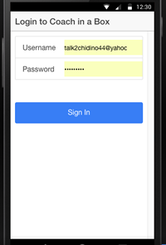 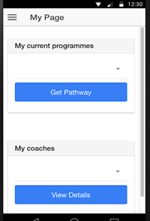

Fig 6.1: Login View Fig 6.2: Home View

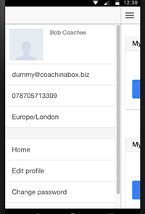 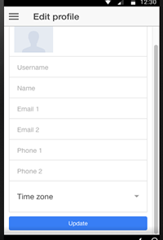

Fig 6.3 Side Menu View Fig 6.4: Edit Profile View

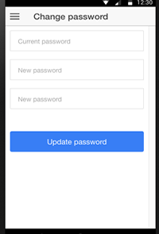

Fig 6.5: Change Password View

Also the Ionic Creator doesn’t support – at the time of use, tabs and side menu: it was one or the other. I found the preview feature helpful, as I was able to preview how the UI looked whilst designing it.

Regardless of its limitations, the author found the Ionic Creator to be very useful. The author used two days to create this initial high-fidelity design. The demonstration to the client was received favourably and the feedback was so good, this initial design didn’t warrant any change.